CALL to ACTION
in solidarity with Minidoka!
BACKGROUND
Just north of Minidoka, LS Power, a New York private equity firm, is seeking approval from the Bureau of Land Management (BLM) to build 400 wind towers as high as 740 feet tall, with several towers located on the historic footprint of Minidoka National Historic Site, a World War II Japanese American incarceration camp. LS Power wants to build towers within two miles of the park’s new visitor center.

Approximately 340 towers will be visible from the park on a clear day. They will form a visual wall of towers that will dominate about one third of the park’s 360-degree view (also known as a “viewshed”). Each of the towers could be taller than the Space Needle (604 feet). With turbine blades the length of the wingspan of a Boeing 747, each of the 340 towers visible from the park will create a visual impact equivalent to a 747 wing rotating on the Space Needle. At night the towers will be lit with red warning lights for aircraft. If built, it would be one of the largest wind projects on U.S. soil.

The National Park Service (NPS) has stated that the towers "will fundamentally change the psychological and physical feelings of remoteness and isolation one experiences when visiting Minidoka NHS." Secretary Deb Haaland heads the Interior Department which includes both the NPS and BLM.
OUR GOAL
Our goal is to help BLM and DOI understand your connections to Minidoka and the types of impacts that the massive wind project will have on you, your families, the Japanese American community and the public.
Specifically, we recommend highlighting three things:
- Painful experiences from the incarceration at Minidoka, or afterwards.
- Benefits to you of Minidoka National Historic Site, e.g. a pilgrimage or family reunion
- Impact of the wind project on you
At the request of LS Power, the BLM is preparing an Environmental Impact Statement (EIS). Federal law requires an EIS for large projects to ensure that decision makers take a “hard look” at the impacts of LS Power’s proposal on the environment.

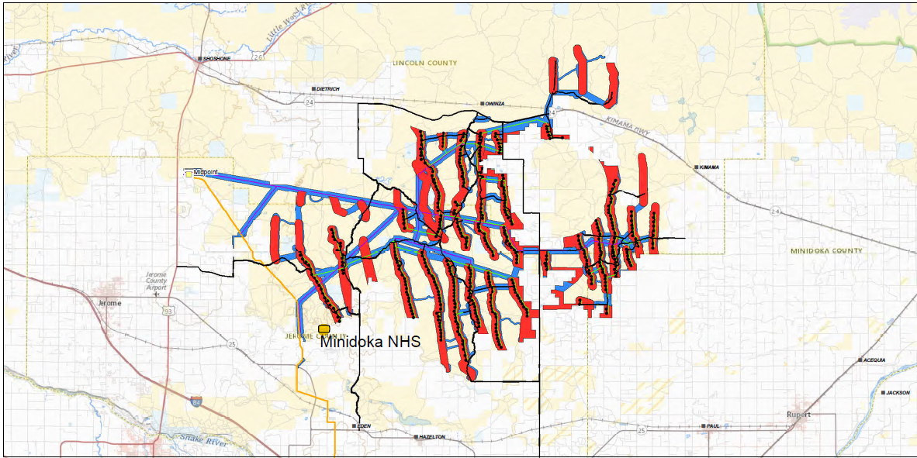
At the beginning of the process, BLM seek comments from the public called the “scoping period.” During the “scoping period,” we want to voice our concerns and to identify the types of impacts that will need to be studied in the draft EIS in 2022. The public scoping comments are due on October 20, 2021. The entire process could take one to two years, but the Biden Administration is fast tracking sustainable energy projects.
WHAT WE NEED FROM YOU
Make your voice heard!
Write a “public scoping comment.” Please focus your comments on three key points:
- The emotional pain caused by the U.S. Government’s decision to incarcerate Japanese Americans during World War II. We seek to convey that the pain continues to this day..
- What Minidoka National Historic Site means to you and your families.
- The impact of the proposal on you and your family.
We want to help key decision makers and elected officials understand how important this is to you
YOUR VOICE MATTERS. YOUR STORIES MATTER!
HOW TO WRITE AN EFFECTIVE PUBLIC COMMENT
We are not providing a group letter to sign on to, or a form letter. We recommend that comments are personalized and unique in order to be considered substantive, and your individual stories are powerful and important. (Please note that our conservation partners are working to generate large numbers of public comments.)
We suggest this heading:
Mr. Kasey Prestwich
Project Manager
Shoshone Field Office – Bureau of Land Management
400 West F Street
Shoshone, ID 83352
[INSERT DATE HERE]
Dear Mr. Prestwich:
Thank you for the opportunity to submit comments to the Bureau of Land Management regarding LS Power’s Lava Ridge Wind Project.
We suggest the following format:
- Suggested talking points
- Your personal stories – focus on three part discussion, if you wish
- Closing

- Suggested talking points:
- The Minidoka National Historic Site is sacred land to me and my family.
- Established as a National Monument in 2001 and designated as a National Historic Site by Congress, the National Park unit acknowledges the injustice of U.S. Government actions against Japanese Americans in World War II.
- For over 20 years, the National Park Service’s stewardship of the site has served as a source of strength and healing for Japanese Americans and other people of color who have suffered injustice at the hands of our own government.
- Minidoka also provides educational opportunities for the public to learn that prejudice against the Asian American Pacific Islander (AAPI) communities is not new. It is part of a network of Japanese American camps and other sites of conscience, managed by the National Park Service (NPS) for the benefit of current and future generations.
- By law, the National Park Service is required to manage the park’s fundamental resources and values unimpaired for future generations. As stated in the Park’s Foundation Document, these values include:
- Environmental Setting: “Minidoka’s remote location in the high desert of Idaho provides an immersive setting that is fundamental to the visitor experience. Views of open fields and distant mountains create a sense of isolation on a vast landscape where Minidoka once stood…Extreme changes in temperature, the arid environment, and high winds that the people at Minidoka experienced are part of the environmental setting that are felt today. Experiencing this environmental setting allows visitors to better understand and connect to the daily lives at Minidoka.”
- Commemoration and Healing: Minidoka provides a place “… for engagement, reflection, and healing. These sites provoke connections to individuals affected by the World War II exclusion, forced removal, and unjust incarceration, and serves to commemorate those who survived this difficult chapter of American history.”
- Public Understanding, Education, and Involvement: “Educating and engaging the public in understanding the history of the incarceration of Japanese Americans during World War II, the fragile nature of civil rights, and the need to protect civil and constitutional rights in the United States is essential...At Minidoka, special events such as the pilgrimage and the civil liberties symposium connect the public to the history that occurred here and its significance today.”
- LS Power’s wind project would make it hard to experience the sense of isolation and remoteness needed for healing, learning and commemorating our ancestors.

- Personal stories:
Please consider writing about you/your family history including information about you or your family members. We recommend focusing on the impact of the camp on you and your family, the benefits Minidoka has provided and your concerns about the wind project.
Camp survivors can write in the first person with “I” statements. The model below is written in the third person, as a descendant. This is just a model. These comments will be included in the public record and available for review. After the public comment period is over, we plan to collect the comments to share with elected officials and other key decisionmakers.
Your story is unique and powerful. Please put as much detail as you are comfortable with sharing.
- Place where they lived before camp. “My mom lived in Bellevue, Washington before the war. Her parents cleared the land for a strawberry farm.”
- What happened after Executive Order 9066. “The government imprisoned my mom and her family, my grandparents, in the Puyallup fairgrounds, where they lived in horse stables. They lost the farm because they couldn’t pay taxes and it was developed.”
- Describe camp life and how it affected you/your family. “Camp was really hard for her. My grandparents never recovered.”
- Please include your camp address, if you have it. (Barrack block #)
- Describe what happened after camp. “She settled in Chicago, where she became a teacher. She never talked about her experience. It was too painful for her.”
- Describe your experiences at Minidoka and what it means to you. “My mom and I attended pilgrimages in 2005 and 2007, before she passed. The visits to the park gave her a sense of closure. She was gratified by the U.S. government’s acknowledgment that what happened to her was wrong and that the American people can learn from our story to prevent it from happening again.”
- Describe your future plans. “I plan to go to the next pilgrimage. It will help me with the grief from losing my mom and the pain from the recent violence against the Asian American Pacific Islander (AAPI) community. I want my children to understand my mom’s story including the courage it took to endure in camp, but also the impact it had on her. It helps to be with other people at pilgrimage who have suffered terrible pain, mostly in silence, for almost 80 years.”
- By surrounding Minidoka with hundreds of giant wind turbines, the project would make it hard for me to draw strength and solace from annual pilgrimages. It will make it hard to experience that same sense of remoteness and isolation experience by incarcerees.
- Describe the impacts that these towers would have on you when you visit the site in the future.
Closing statement:
LS Power’s proposal would dishonor our nation’s acknowledgment that the incarceration of Japanese Americans was wrong.
It will destroy Minidoka’s ability to commemorate our parents and grandparents and serve as a place of healing and learning.
It will desecrate sacred ground.

HOW TO SUBMIT YOUR PUBLIC COMMENT
- The deadline to have your “public comment” included is WEDNESDAY, OCTOBER 20th!
- For more information, please check the BLM website: https://eplanning.blm.gov/eplanning-ui/project/2013782/510.
- There are three ways to submit ”public comments:”
  - Email your comments to Kasey Prestwich, Project Manager, BLM Shoshone Field Office: BLM_ID_LavaRidge@blm.gov
  - Mail them to: Kasey Prestwich, Project Manager, BLM Shoshone Field Office, 400 West F Street, Shoshone, ID 83352 (Must be postmarked by October 20th)
Tel. 208-732-7204
  - In addition to comments, you can submit photos and videos to be included in the record. The BLM can accept comments with up to 20 MB of attachments. If the photos and videos exceed 20 MB and are available in the public domain, you can reference them in your comments. How to submit electronically via the BLM Land Use Planning and National Environmental Policy Act Register: Navigate to https://go.usa.gov/xFKxg and click on “documents” button on the left. the “Participate Now” button to the right of the document link. Enter your comment and information, then click “Submit” Please add the context associated with any photos or videos.
- Please note that your comments will be included in the public record and available for review by people outside the government. The BLM will not release your personal information.
- Please share copies of your letters with:
  - Friends of Minidoka at info@minidoka.org
  - Minidoka Pilgrimage Committee at minidokapilgrimage@gmail.com
- With your approval, we may ask to use your stories in these letters as part of the fight against the proposal.

