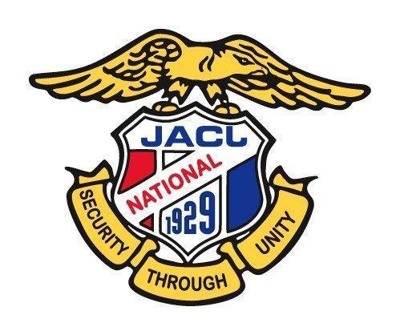
JAPANESE AMERICAN CITIZENS LEAGUE
54th JACL National Convention
Philadelphia, PA July 10-14, 2024

DISTRICT YOUTH REPRESENTATIVE FORM

Guidelines:
- Completed form must be emailed or postmarked no later than Saturday, May 11, 2024.
- Options for sending form:
- Email completed form to credentials@jacl.org (must be signed and scanned – or – type in name and write “Please accept this as my official signature”)
- Mail signed and completed form to (least preferred):
JACL Credentials Committee, 1765 Sutter Street, San Francisco, CA 94115

Each District is entitled to two (2) District Youth/Student Representatives. The following person(s)
will be the Youth/Student Representative(s) for the _______________ District at the 54th JACL National Convention.

DISTRICT YOUTH REPRESENTATIVE

Name: _______________________________ Name: ________________________________

Phone: _______________________________ Phone: ________________________________

E-Mail: _______________________________ E-Mail: _______________________________

_____________________________________________________________________________
Signature of District Governor Print Name Date

